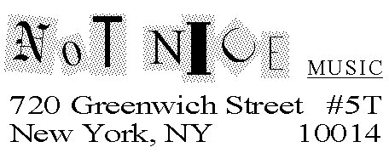
December 2, 2004

Literary Agent
Literary Agency
Literary Agency’s Street Address
Literary Agency’s State, City, Zip

Dear Mr./Ms. Agent,

Why, despite unprecedented access to historical masterpieces, do we continue to create new aesthetic experiences?
Because we like to play.
That’s the central thesis of Play, a playful, sometimes irrelevant, often controversial collection of essays, poems, song lyrics and indefinable writings that seek to bring the subject matter of such classic, best-selling, and long-term selling books as Virgil Thomson’s “The State of Music,” John Cage’s “Silence,” and the Pulitzer Prize-winning “Gödel, Escher, Bach” into the twenty-first century.
Intended for a general, not an academic, audience, Play does not pander to the assumptions or ideologies of either. Like those books cited above, readers throughout the United States, and throughout the world, will buy Play because it will make them smarter.
I am well-known in the new music-theatre and contemporary classical music fields as an author, composer, performer and theorist. I’m on the Editorial Advisory Board and a columnist for New Music Connoisseur, and I’ve been published in NewMusicBox and in Twentieth Century Music, which called me “an authority on contemporary music-theatre and opera.” Actually, I prefer the time I was called “the biggest thinker in show business.”
If you’d like to receive the book proposal for Play, please write to the address above (SASE enclosed), or contact me by telephone or e-mail. Please be aware that this is a multiple submission.
Care to play?

Barry Drogin/Not Nice Music
barry@notnicemusic.com/212-929-6335

