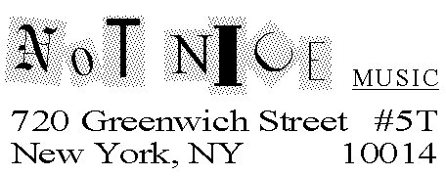
January 26, 2006

Literary Agent, Literary Agency
Literary Agency Address

Dear Mr./Ms. Agent,

With ready access to a glut of masterpieces, why do artists continue to exist and create? Simple: because we like to play.
That’s the central thesis of Play, which brings the subject matter of evergreen books such as “Silence,” “The State of Music,” and the Pulitzer Prize-winning “Gödel, Escher, Bach” into the new century. Play is itself a playful, irrelevant, controversial sketch-comedy melding of a book with poems, song lyrics and other indefinable writings.
For a general trade audience, at times very funny, and always readable, the unedited 56,000 word manuscript is complete, and a book proposal with a killer marketing plan, complete table of contents, and sample chapters is yours for the asking. I’m also at work on a second book, and already collecting ideas for a third.
Who am I? I’m Barry Drogin, well-known as a comic author, composer, performer and theorist, the P.D.Q. Bach, as it were, of new music and new music-theatre. I’m a New Music Connoisseur columnist, composer (and annual performer internationally) of the “NewOp Doo Wop” theme song, well-connected C-Opera listserv moderator, with feature articles published in NewMusicBox and Twentieth Century Music (which called me “an authority on contemporary music-theatre and opera” - although I prefer when, in front of an audience convulsed with laughter, an emcee called me “the biggest thinker in show business!”).
If you’d like to receive the book proposal for Play - and who wouldn’t want a sneak peak at this bestseller? - please write to the address above (SASE enclosed), or contact me by telephone or e-mail. Please be aware that this is a multiple submission!
Form letter rejections gladly accepted, as well as anecdotes about how you later kicked yourself for missing this opportunity. Author available at book readings to provide 15% of the kick.

Barry Drogin/Not Nice Music
barry@notnicemusic.com/212-243-8784

